Assignment Problems: Day 5

The following problems require access to the file named ‘Dataset_Day5.csv’, provided with this assignment. (Everyone must use Random State = 100)
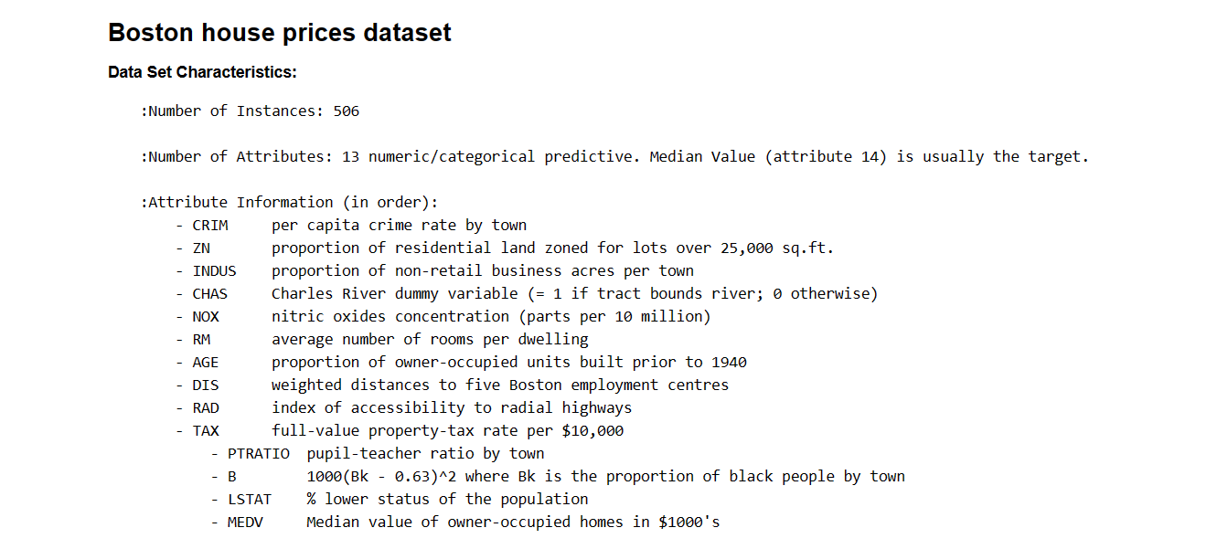
Problems to solve –
- Perform a complete data inspection including – (20 marks)
  - Outliers, Missing Data Treatment
  - Descriptive Statistics of each variable (Eg. Boxplot, Histogram etc.)
  - Visualization of all continuous variables

- Create a simple linear regression model that quantitatively relates ‘MEDV’ with ‘RM’. (10 marks)
  - Share the model performance metrics and print the full regression model with coefficients.
  - Use the model to predict the price of the house for ‘RM’ = 7

- Create a simple linear regression model that quantitatively relates ‘MEDV’ with ‘DIS’. (10 marks)
  - Share the model performance metrics and print the full regression model with coefficients.
  - Use the model to predict the price of the house for ‘DIS’ = 15

